# Bookstore manager Python app integrated with MySQL DB

|  |  |
| --- | --- |
| Student name | ID |
| Mohamed ElGemeie | 20200026 |

# Business rules

This project aims to assist a bookstore/ café that serves beverages , and sells books, prints, and monetizes Wi-Fi. The business owner requests to calculate a Wi-Fi charge tagged with each table in the store, calculate the total receipt of any transaction, and store any sold books with relevant information.

## Remarks

* There are three types of transactions (Instore, takeaway, print/books).
* Each transaction type has a start time.
* A transaction could have one or more items, and an item could be had by one or more transaction.
* Each item has a price, a takeaway price, and a name.
* Instore transactions store the end time and table number of the transaction.
* Print/Book transactions have a name, total price, and amount.
* A transaction could only be either a takeaway, or instore, or print, and not both at any time.

## Database Design

ERD:

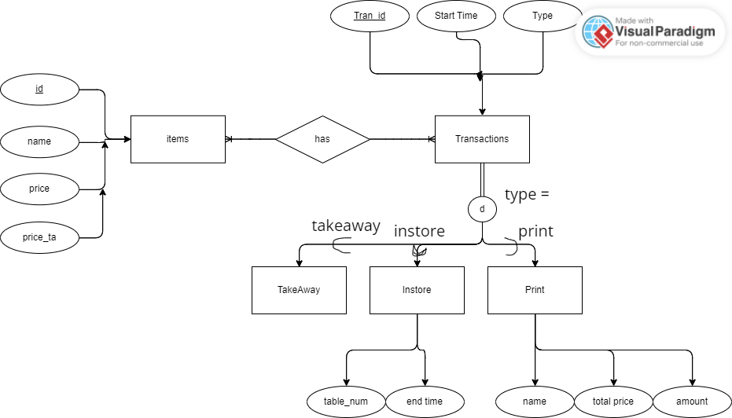

MySQL DB design:

### Functional dependencies:

Print_stock:

* Id -> {id, name, total price, amount, tran_id}

1st normal from

Transactions:

* Id -> {start time, type}
* Start time -> {id, type}

BCNF normal form

Instore:

* Id -> {tran_id, table number, end time}
* End time -> {id, tran_id, table_num, id}

BCNF normal form

Order_group:

* Id -> {item_id, tran_id}

1st normal form

Item:

* Id -> {name, price, price_ta}
* Name -> {id, price, price_ta}

BCNF normal form

# Results

